FIRE AND LIFE SAFETY PLAN
AND PROCEDURES



101 W. Goodwin
Victoria, TX 77901
(361) 570-2028

LIFE SAFETY IS THE GOAL OF THIS PLAN, ALL DUTIES CALLED FOR HEREIN SHOULD BE DONE FROM A SAFE LOCATION IF POSSIBLE

TABLE OF CONTENTS

Introduction 1
Emergency Telephone Numbers 2
Evacuations 3
Special Instructions for Persons with Disabilities 4
Emergency Evacuation Team Responsibilities 5-6
Fire 7
Procedures for Reporting Fires and Fire Alarm 7
Procedure 8
Tenant Responsibilities 9 Building Staff Responsibilities 10
Elevator Emergency Procedures 11
Bomb Threats 12-14
Suspected Bomb Threat – Safety Procedures 16
Procedures for Receiving Bomb Threats 17
Disasters/Medical Emergencies 17
Tornadoes 18
Hurricanes and Floods 19
Earthquakes 20
Earthquake Procedures 21
Power Failure 22
Medical Emergencies 23
Prevention 24
Bomb Threat Checklist 25
Persons with Disabilities 26
Warden Information Sheet 27
Emergency Preparedness and Evacuation Team 28
Floor Plans 29
Fire Alarm System Operations 35
Building Fire Safety Features 36
Specific Instructions for Elevator Operation 37
Public Address Announcements 38
Introduction
The landlord-tenant relationship is one of mutual dependence and responsibility. This relationship is most important when discussing fire and safety issues. You depend on the building management to provide you with information and instructions on how to respond during an emergency. Similarly, we depend on you—and all of the tenants to become familiar with that information and participate in evacuation drills and training sessions.

Throughout the following Emergencies section we will refer to the safety/evacuation director, floor wardens, tenant wardens, searchers, and various monitors. These are people in the building who have been assigned specific duties to perform during an emergency. Please refer to the Evacuation section of this manual for more information on the responsibilities of each of these positions.

If you have any questions about the procedures and plans in this manual, please do not hesitate to contact the management office at 361-570-2028.

ONE O'CONNOR PLAZA

Emergency Telephone Numbers

All Emergencies 911

Fire Department (non-emergency) (361) 573-3221

Police Department (non-emergency) (361) 573-3221

Management Office (361) 570-2028

After Hours Building Emergency Number/Security (361) 570-2028

Report Power Outage to - AEP Texas (866) 223-8508

Gas Company - CenterPoint Energy (866) 427-7142

Floor / Tenant Warden(s)

Stairway Monitor(s)

Elevator Monitor(s)

Special Assistants (Monitors for Persons with Disabilities)
Persons w/ disabilities*

Persons with CPR Training

A copy of this page should be distributed to all employees.)
Evacuations
General Information
Each tenant is obligated to follow the Emergency Preparedness and Evacuation Plan established by O’Connor Building Partners, L.P. The tenant shall provide responsible personnel to assist the management office and be responsible for controlling the movement of tenant employees during an evacuation of the building.

The Emergency Preparedness and Evacuation Plan includes the following people:

- The Property Manager, who is in charge of the procedures and the specific responsibilities of those assigned in the plan.
- Sufficient floor wardens and tenant wardens, to ensure that an evacuation team is in force in all occupied portions of the building and public areas (i.e., lobbies, corridors, exits) during an evacuation.
- A representative is selected by each tenant and assigned the duties of floor warden or multiple tenant floors will each have a tenant warden The floor or tenant warden remains in contact with the management office during all emergencies.
- Sufficient searchers and monitors assigned to appropriate areas of the building, to ensure that all employees are evacuated from remote areas, and that evacuation takes place in an orderly and safe manner.
- Sufficient alternates assigned for each position specified in the plan, so that a principal or alternate is always in the building during working hours to supply leadership under the plan.
Tenant Responsibilities
Each tenant should establish an emergency team based on the positions described above. A floor or tenant warden serves as the contact point between the management office and the tenant’s employees, ensures that every employee of the tenant is aware of all emergency procedures and plans, and coordinates tenant response in an emergency.

The emergency team for each floor consists of the floor warden, tenant warden(s), searchers and monitors.
Evacuation Drills
- The property manager conducts emergency evacuation drills, at least annually, in accordance with the approved plan.
- All occupants of the building are required to participate in the emergency evacuation drill. The occupants may be required to leave the building and assemble in an area designated by the property manager.
- A written record of the drills are kept on the premises and readily available for inspection by the fire department.

Special Instructions for Persons with Disabilities
Persons with disabilities must be identified and considered prior to any emergency evacuation. It is necessary for tenant wardens to notify the floor warden and property manager of any persons with disabilities who may require special assistance during an evacuation. A list must be maintained by the tenant warden and updated as necessary. (See Exhibit C).

Persons not requiring or providing assistance will evacuate first. The assisted persons can then evacuate without being bumped or pushed down, thus speeding evacuation and avoiding injury. If there is evidence of fire, persons with disabilities should be positioned near the fire exit stairs located farthest away from the fire. If fire conditions pose a personal threat, the special assistants will enter the exit stairwell accompanying the person with disabilities and wait for special assistance from the fire department. The evacuation brigade may assist in evacuating the persons with disabilities if danger is imminent and the fire department has not yet arrived.

Emergency Evacuation Team Responsibilities
Property Manager
- Be familiar with the written Emergency Preparedness and Evacuation Plan.
- Organize, train, and supervise the chief engineer.
- Designate the floor warden for each floor, and sufficient tenant wardens for each tenant in accordance with the Emergency Preparedness Evacuation Plan.
- Organize, train, and supervise the floor wardens and tenant wardens.
Chief Engineer
- Be familiar with the written Emergency Preparedness and Evacuation Plan.
Floor and Tenant Wardens
- Be familiar with the Emergency Preparedness and Evacuation Plan, the location of exits and the location and operation of any available fire alarm system.

- Ensure that the assigned responsible and dependable employees are selected as wardens, and monitors. For specific tasks, refer to the emergency sections listed under Fire, Bomb Threats, Severe Weather, Tornadoes, Hurricanes & Floods, Earthquakes, Power Failures and Medical Emergencies.

- Organize, train, and supervise the searchers, stairway monitors, elevator monitors and special assistants.

- Direct the evacuation of occupants in the event of emergency. Floor wardens are assisted in their duties by tenant wardens. A tenant warden is assigned for/by each tenant.

NOTICE TO ALL FLOOR WARDENS AND TENANT WARDENS: It is your responsibility to inform the property manager of any vacations, leaves of absence, transfers, or sickness of yourself and tenant wardens, in order to make necessary provisions for alternates.
Searchers
1. Find and evacuate all personnel from the suite, specifically from remote areas such as storerooms, file rooms, computer rooms, core areas, etc.
Special Assistants (to aid persons with disabilities)
- Make sure all persons with disabilities are evacuated.

- Maintain an up-to date list of persons with disabilities in your suite. If possible a buddy system will be implemented in which one or two special assistants will be responsible for evacuating specific co-workers.

Stairway Monitors
- Assigned to a specific exit area, ensure that everyone exits into the stairwell in an orderly and safe manner.
Elevator Monitors
Make sure no one uses the elevators unless assisted by the fire department.

Fire
PROCEDURES FOR REPORTING FIRES & FIRE ALARMS

If you discover smoke or fire:

1. Dial 911 immediately.

2. Inform the fire department dispatcher that you are calling to report a fire at One O'Connor Plaza, 101 W. Goodwin. Tell the fire department dispatcher:

- Your name
- Your company’s name
- Your suite/floor number
- What is on fire
- The location of the fire
- Your telephone number

3. Listen to the dispatcher for any additional instructions before hanging up.

4. Call the management office at 361-570-2028.

5. Activate the nearest manual fire alarm pull station at the location shown on the attached floor plan.

6. Evacuate according to the Emergency Preparedness and Evacuation Plan.

7. If you think you smell a peculiar or unfamiliar odor, call the management office IMMEDIATELY at 361-570-2028, to report the location of the odor

(A copy of this page should be distributed to all employees.)

General Information
The building must be evacuated when a fire alarm signal is sounded. An effective evacuation depends on the orderly ‘phasing’ of floor clearance, which means that the emergency floor is evacuated first and immediately. The next floor to evacuate should be the floor above the emergency floor, followed by the floor below. The property manager will be in charge of the evacuation until the fire chief arrives.

Each tenant office manager or supervisor must predetermine priorities for the safety of records, classified material and/or securities. Supervisors also must cooperate with tenant wardens to ensure that all employees are well-informed and instructed on evacuation procedures.
Procedure
- The person who discovers the fire:

- Dials 911 and reports the fire to the fire department.
- Calls the management office at 361-570-2028 to report the location of the fire.
- Activates the fire alarm pull station (FAPS).

2. The floor wardens will contact the tenant wardens, and monitors the special
assistants assigned to their floor. In addition, the floor wardens assume full control
of their floor and activate the Emergency Preparedness and Evacuation Plan.

3. The tenant wardens go into immediate action. Absolute silence and decorum must prevail for maximum effectiveness. Also, no smoking is permitted during an evacuation.

4. Special assistants immediately contact and help the disabled person assigned to them. assigned person. Persons with disabilities wait for help from their special assistant.

5. The stairway and elevator monitors go to their stations and perform their assigned duties.

6. Members of the evacuation brigade go to their stations and perform their assigned duties.

7. The floor warden, under instructions from the management office, orders the fire floor to evacuate.

8. All elevators are automatically called to the ground floor . The evacuation brigade promptly clears the ground floor lobbies by directing all people outside to avoid lobby congestion.

9. As each floor is evacuated, the stairway monitors make sure all stairway doors are closed after the last person evacuates the floor.

10. Floor wardens distribute the flow of people evenly via all available stairway exits.

- If a stairway is filled with smoke or on fire, the alternate stairway can be reached via cross-over through the closest tenant floor.
- Each stairway designated as an evacuation stairway is identified by signs on the inside and outside of the door at eye level. When floor wardens report to the security desk on any condition, they must refer to their location as evacuation stairway.

11. The orderly phasing of floor clearance continues until all occupants are evacuated to the outside safety area, which is located no less than 300 feet from the building; which is DeLeon Plaza for all building tenants other than Wells Fargo, who will meet at the First Baptist Church's parking area.

12. When the “all clear” is announced, the property manager or chief engineer signals the floor wardens to lead the employees in an orderly fashion back to their work places. If available, elevators will be back in service. The evacuation brigade coordinates the loading of the elevator cars to prevent over-crowding. Single floor groups should enter an elevator together.

13. The intermittent Alarm Signal is silenced when the “all clear” is announced. (The alarm signal continues throughout the state of emergency.)

NOTE: Upon arrival, the fire chief is in charge.

Tenant Responsibilities
Special Assistants (to aid persons with disabilities)
1. Evacuate persons with disabilities.
2. If necessary, ensure persons with disabilities are carried by their assigned assistants. Wheelchairs should be left behind.
Floor Wardens
1. Direct the evacuation of the floor in accordance with the directions received from the management office and the following guidelines:

- Ensure all occupants are notified of the fire and immediately execute the Emergency Preparedness and Evacuation Plan.

- Know where all persons with disabilities are located and keep an up-to-date list. These persons may need special assistance in the event of evacuation.

- Select the safest stairwell to use for evacuation from the floor based on the location of the fire and the commands and directions received from the Fire Command Center and await further instruction.

- Shall make sure all tenants in their charge are available and ready to disembark the Floor, when commanded to do so.

- MAKE SURE PERSONNEL DO NOT USE ELEVATORS DURING EVACUATION.

2. Before anyone enters the stairwell to evacuate, check the environment in the stairwell. If it is affected by smoke, select an alternate stairwell and notify the management office at 361-570-2028.

3. Please keep the management office informed of the means being employed for evacuation by the occupants of your floor and other pertinent information if the stairwells are obstructed.

Building Staff Responsibilities
Property Manager
1. Report to the Fire Control Center to supervise, coordinate and ensure that:

- The fire department has been notified of any fire or fire alarm.
- All elevators have been called to the ground floor or second floor.
- The fire department is given all emergency keys
- Evacuation procedures are followed as outlined in the Emergency Preparedness and Evacuation Plan.
- The fire department chief-in-charge is advised of the operation of the fire command station.
- The conditions on the fire floor are reported to the fire department.

Chief Engineer
- Report to the Fire Control Center to assist the property manager to effect implementation of the Emergency Preparedness and Evacuation Plan.
- Reports to fire command station to verify the alarm area, and provides
information to assistant safety evacuation director
- Is prepared to direct the fire department to the fire location and to inform them of
conditions.

- In the absence of the property manager, assume the full duties and responsibilities of that position.

- Provide the fire department and police department with building information (floor plans, blueprints, etc.) as requested.

Elevator Emergency Procedures

Upon notification of someone trapped in an elevator or you become trapped in an elevator the following instructions are to be utilized:

1. Use the emergency phone / call button.
- The button or phone is located behind the door on the lower left side of the elevator panel.
- These devices are self-dialing and connect you to a 24-hour elevator answering service.

2. Use your cellular phone
- Elevator 24 hour answering service direct line: 800-759-3538
- Call 911, Fire and Police Department Emergency Number
- Call the management office at 361-570-2028.

3. Notify others within the vicinity of the elevator(s)
- By pressing the emergency alarm button, that sounds an audible alarm that can be heard by people walking by the elevators.
- By shouting if necessary to attract attention.

4. Remain CALM and STAY in the elevator car
- Do NOT attempt to force open/or exit the elevator.
- Wait for the Elevator or Fire Department/Rescue personnel and follow their instructions upon their arrival.
- As a last resort, in the unlikely event that you are not able to communicate with the elevator answering service due to technical, mechanical failures, call 911 and advise them of your situation and location.

5. Provide the following information
- Your name.
- The building name, One O'Connor Plaza.
- The street address, 101 W. Goodwin.
- Elevator number, located on the elevator telephone door and floor if known.
- Remain on the line until told to hang up.

Bomb Threats
General Information
Fortunately, the vast majority of bomb threats are false alarms. Unfortunately, it is difficult to differentiate false alarms from genuine threats. As little publicity as possible should be given to the incident, since the objective of the caller is usually to disrupt normal business functions by causing the building to be evacuated.

The Griffin Partners staff will endeavor to control unauthorized access to this facility. The success of the preventive strategy requires full cooperation from all tenants. All contractors performing work or vendors delivering supplies are to report to the management office for special identification tags. All suspicious individuals or situations should be reported at once to the management office at 361-570-2028.
Procedure
1. The person who receives the bomb threat call:

- Gets as much information from the caller as possible using The Bomb Threat Checklist
(Exhibit A) as a guideline.
- Dials 911 and report the threat to the local police or fire department
- Call the management office at 361-570-2028.

If a non-descriptive general bomb threat is received (no description of bomb, no detonation time, no location, etc.), the building will remain open. The decision to evacuate is then the responsibility of each tenant. Total evacuation may be necessary when the threat is specific in nature, the call cannot be resolved as a hoax, or a suspicious object is located. If total evacuation is necessary, the Bomb Threat Notification Procedure (Exhibit C) will be executed. For evacuation procedures, please see the Fire section.

NOTE: Two-way radios may detonate some explosive devices. Therefore, two-way radios should not be used during bomb threats.

2. The management office contacts all floor wardens. The property manager and floor wardens confirm the need to notify company employees of the threat and to evacuate the building.

3. The floor wardens contact the tenant wardens, searchers and monitors assigned to their floors. In addition, the floor wardens assume full control of their floors and activate the Emergency Preparedness and Evacuation Plan.

4. Tenant wardens notify employees in a calm and deliberate manner.

- Carefully worded pre-planned statements can convey the urgency of the situation without causing panic. An appropriate statement might be, “Employees are directed to immediately cease work, gather their personal belongings and proceed to (the emergency stairwell or floor [x]). This is not a drill.”

5. Tenant wardens execute their bomb threat search plan, making sure they:

- Search for objects that seem out of place.
- Do not touch anything! Suspicious objects MUST NOT be tampered with.
- Notify the management office immediately at 361-570-2028 if they have found a suspicious object. (The management office will then notify the fire department, who will subsequently assume full control of the operation.)

6. The chief engineer reports to the affected area of the building and begins a search of the following areas:

- Public areas
- Stairways
- Elevators
- Equipment rooms
- Cleaning closets
- Restrooms
- Air handler rooms
- Any other areas designated by the police

7. Floor wardens search the common areas of their floor including the following areas:

- Public Areas
- Stairways
- Restrooms

8. Floor wardens inform the management office 361-570-2028 of all new developments.

NOTE: If your company decides to evacuate the building, use the stairways to evacuate. The tenant warden must confirm with the property manager that your company has evacuated the building.
Tenant Responsibilities
1. Evacuation. If a non-descriptive general bomb threat is received, the building will remain open. The decision to evacuate is then the responsibility of each tenant.

2. Search leased space for bombs.

3. Develop a Bomb Threat Search Plan to be executed upon receipt or notification of a threat and select people to participate in it.

4. IMPORTANT - If you determine that your employees and visitors are in imminent danger and you cannot reach the building management office by telephone, 361-570-2028, in a reasonable length of time, you may determine if prudent to exercise you independent judgment and evacuate your personnel. Report to the building manager when evacuation is complete and all personnel are accounted for.

Building Staff Responsibilities
Property Manager
1. Assist tenants who have received a bomb threat. Requesting:

- Specifics of the threat.
- If 911 has been called. (If not, the property manager will call 911.)
- If a bomb search has been initiated. (The property manager will remind the tenant that it is their responsibility to search their own leased space.)
- If employees have been notified of the threat.

2. Notify the floor wardens, security and the evacuation brigade.

3. Execute the Bomb Threat Notification Procedure (Exhibit B).

Preventative Measures
- Conduct regular inspections in every suite for suspicious objects. Neat offices that are free from debris and boxes can make a foreign object easier to detect.
- Encourage all employees to report any suspicious persons wandering about the offices, corridors and restrooms to the management office at 361-570-2028.
- Monitor all delivery people and repairmen while in your office. Do not leave your office unattended and unlocked for any reason. All drawers, cabinets, compartments, closets, etc. fitted with locks should be kept locked.
- Encourage all employees to comply with the building security access control measures.

SUSPECTED BOMB – SAFETY PROCEDURES

The Safety Precautions enumerated below are designated to acquaint you with the dangers inherent in the search, discovery and handling of “Suspected Bombs”, upon either notification of a bomb, or if you have other reason to be suspicious.

While some of the following Safety Precautions may seem elementary, do not dismiss them as unimportant, nor take them for granted – because adequate knowledge of their precautionary provisions may save your life, the lives of your fellow Employees and Tenants and the lives of the individual customers and Visitors who daily frequent the building.

- Do not use radio equipment to transmit messages.
- Do not “change the lighting conditions”. (Turn switches on/off)
- Do not smoke!
- Do not accept the contents of any container as “bona fide”, simply because it was delivered by “routine means”!
- Do not accept container markings and/or appearance as sole evidence of their contents, identification and legitimacy!
- Do not touch a “suspected bomb”.
- Do not shake, shock, or jar a “suspected bomb”.
- Do not cover a “suspected bomb”.
- Do not carry a “suspected bomb”.
- Do not assume that a “suspected bomb” is of a specific (high-explosive or incendiary) type!
- Do not open any “suspicious” container or object!
- Do not cut a string, cord, or wire on a “suspicious” container or object!
- Do not cut or remove the wrapper on a “suspicious” container!
- Do not unscrew the cover of a “suspicious” container or object!
- Do not move the “latch” or “hook” on the cover of a suspicious container or object.
- Do not raise or remove the cover of a “suspicious” container!
- Do not change the position of a “suspicious” container or bottle!
- Do not place a “suspicious” container into water.

ONE O'CONNOR PLAZA
101 W. GOODWIN

If You Receive a Bomb Threat Over the Telephone

1. Complete Bomb Threat Checklist, if possible. (Exhibit A).

2. Call 911.

3. Inform the dispatcher that you are calling from One O'Connor Plaza at 101 W. Goodwin, and you have received a bomb threat. Tell the dispatcher:

- Your name
- Your company’s name
- Your suite/floor number
- Your telephone number
- Any information from your Bomb Threat Checklist

4. Listen for instructions.

5. Call the management office at 361-570-2028.

6. Wait for further instructions from your tenant warden.

(A copy of this page should be distributed to all employees.)

Disasters/Medical Emergencies
Severe Weather
The US Weather Service reports the movement of severe weather that may present a threat to the metropolitan area. Tenants have the choice of evacuating or remaining in the building during a severe weather alert. If an early alert is given by the US Weather Service, certain steps can be taken to prepare for the severe weather if the decision is to remain.
Tenant Responsibilities
All Tenants
1. Maintain an inventory of emergency equipment to be used during severe weather.

- Flashlights and fresh batteries
- First aid kits to treat minor injuries
- Portable radios—useful for keeping abreast of severe weather conditions

2. If informed by the US Weather Service that severe weather is imminent, follow the steps below (if necessary):

- Clear desks, tables, and windowsills of books, papers, or other items and secure them in boxes or drawers.
- Move easily moveable furniture away from windows.
- Store all easily moveable office equipment in inside offices.
Tenant Wardens
1. Move all occupants to the core areas of the building (corridors, elevator lobbies).

2. If your company decides to evacuate the building, notify the property manager of your intention to do so. The evacuation stairwells are the only stairwells to be used in a severe weather evacuation.

3. Confirm with the (property manager) that your company has totally evacuated its space and the building.

4. Notify the property manager of all severe leaks, fires, and structural or other damage during or after the storm 361-570-2028.
Building Staff Responsibilities
Property Manager
1. Alert the Chief Engineer for possible action.
Chief Engineer
1. Check the readiness of auxiliary power for emergency lighting.

2. Execute building repairs as quickly as possible.

NOTE: The building staff will maintain communications with public utilities as appropriate and monitor local news and weather reports.

During disasters that cause loss of primary power sources, City Public Service will work to restore service from a stand-by source.

Telephone service may also be interrupted during severe weather. Tenants requiring emergency service should contact their telephone company.

Tornadoes
General Information
Tenants have the choice of evacuating or remaining in the building during a tornado warning. If a tornado warning has been issued by the weather service, a tornado siren is sounded or if the management office has notified you that a tornado warning is in effect. See the Severe Weather section for more information.

Hurricanes and Floods
General Information
As a hurricane approaches the Texas Gulf Coast, we will be taking special precautions to protect the building and ensure the safety of all tenants.

The management office will be keeping a close watch on the progress of the hurricane and will notify all tenants should evacuation become necessary. In the event of an evacuation as directed by the local authorities, all tenants will be requested to leave the building. Evacuation should be completed as soon as possible after being advised to the building personnel will be able to secure the building for the storm. It is imperative that all tenant personnel evacuate. All building systems (elevators, air conditioning and electricity) will be shut down.
Procedure
1. Keep abreast of weather conditions via radio or television.

2. Move important or valuable documents, files, pictures, plaques, hanging objects, calendars, desktop items, and other loose objects from perimeter offices and furnishings to an interior office to protect them in the event of windows breaking in outer offices.

3. Close all doors of perimeter offices. Close all drapes and blinds. Do not tape windows.

4. Power down all computer equipment (including computerized telephone systems) to avoid loss of information when power is disrupted. Raise any equipment off the floor or relocate, if possible, to an interior room.

5. Turn off all office equipment to include copier machines, coffeepots, typewriters, etc.

6. Notify the alarm system company (if your company has one) of the probable discontinuance of electrical service during the storm.

7. Turn off all lights.

8. After a final inspection, close and lock all external corridor doors.

9. Notify the management office at 361-570-2028 of all severe flooding, leaks, fires, structural damage. Upon notice to evacuate, the following measures should be implemented to protect important items in your leasehold area:

(A copy of this page should be distributed to all employees.)
Earthquakes
In the event of an earthquake, do not attempt to leave the building. You are safer within the building until the initial tremors subside. If evacuation is necessary, know where the locations of possible safe refuge areas are outside and away from the building. Beware of falling glass and electrical lines.

1. It is recommended that you have available in your tenant space:

- A first aid kit
- Transistor radio and flashlight with extra batteries
- Heavy gloves in case of broken glass
- Rubber soled shoes
- A 72-hour minimum supply of medication (if on medication)
- One or two bottles of water per employee - rotate regularly

2. Have a plan for reuniting with your family. Have an out-of-state contact person for your family members to contact.

For more information on earthquake preparedness, contact the American Red Cross or your local fire department.

ONE O'CONNOR PLAZA

Earthquake Procedures
During
1. Remain calm. Do not exit the building. Do not use elevators. If you are in an elevator, exit as soon as possible.

2. Take cover under a desk or another sturdy object or against the wall in the core of the building. Protect your head. DUCK, COVER and HOLD.

3. Move away from the building exterior. Stay away from windows, bookcases, filing cabinets and any objects that may fall or shatter.

4. Do not take cover in emergency stairwells.
After
1. Check for injured and assist if possible. Do not move a seriously injured person unless they are in immediate danger.

2. Inspect your floor for damage. Check for fires. Check for gas and water leaks and electrical shorts. If you suspect a gas leak, DO NOT use matches or cigarette lighters or turn on electrical switches or appliances. If you smell gas, immediately contact engineering or security at 361-570-2028.

3. Open doors carefully. Watch for falling objects.

4. Wear shoes for protection from debris and broken glass.

5. Stay away from windows/glassed areas.

6. Replace telephone receivers, in case the telephone system works. Use telephones for emergency calls ONLY.

7. Listen to radio for emergency reports.

8. Do not spread rumors regarding the building condition, extent of damage and injuries. This may cause a panic.

9. Cooperate with the public safety officials.

10. Be prepared for aftershocks.

11. Notify the management office or security of any damage to the building.

(A copy of this page should be distributed to all employees.)
Power Failure
General Information
In the event the building sustains a power failure, emergency lighting is available in the hallways and stairwells and one elevator will be operational; all HVAC equipment, lights, receptacles, elevators and most telephone equipment will not be operational.
Procedure
1. The property manager contacts the electric company to find out the duration of the power outage.

2. Floor wardens check the elevators on their floors to see if people are trapped inside. If there are people trapped the floor wardens will ask them to remain calm and then notify the chief engineer of their location.

3. Elevator monitors report to the elevator lobby on their floors to assist the floor warden in assessing the elevator situation. If people are stuck, the elevator monitor will stay in contact with these people and not leave the elevator lobby.

4. Stairway monitors report to the elevator lobby on their respective floors. If the floor warden leaves the floor, prepare to evacuate according to the fire procedure.

5. If the power is not restored after 15 minutes, all floor wardens proceed to main floor lobby.

6. The chief engineer meets the floor wardens at main floor lobby and informs them of the situation.

NOTE: If the electric company does not know how long the power will be out, or if power will be out for longer than one hour, the building may need to be totally evacuated.

If total evacuation is necessary, it is conducted according to the fire procedure. (For greater detail on the fire procedure, refer to the Fire section of this manual.)
Medical Emergencies
Time is extremely important in the case of a medical emergency. Griffin Partners recommends that all tenants keep a first aid kit unlocked and fully stocked in their suite. It is the tenant’s responsibility to also make sure that employees are aware of its location. The management office requests that tenants provide a list of any office personnel who are trained in CPR. This list is extremely valuable and will be used by building management to locate trained individuals to assist in an emergency.
Procedure
1. The person who discovers the emergency

- Dials 911, telling the paramedics:

- Building address - 101 W. Goodwin
- Your name
- Your company name
- Your floor/suite number
- Your telephone number

- Calls the management office at 361-570-2028

2. The management office directs the emergency personnel to the medical emergency.

3. The evacuation brigade recalls an elevator to the ground floor to transport the paramedics to the floor of the medical emergency.

NOTE: It is crucial that the injured person is not moved. Try to keep the injured person comfortable without moving him/her.

Prevention
Suspicious Activities
Any suspicious activities should be reported immediately to the management office during regular working hours or call the police department at 361-573-3221 if after hours. Building Management is powerless to assist or take police action in criminal matters in a tenant space. Please call the police department. During business hours, management personnel will escort the police officers directly to your suite.
Crime Prevention Message
The management staff is concerned about the safety and protection of our tenants, their employees, and their property. We are conscious of the various criminal activities to which each of us is exposed daily.

To reduce crime, emphasis must be placed on preventive rather that reactive measures. Preventive measures against office thefts, burglaries after hours and crimes against persons can best be achieved through the individual efforts of each employee. To minimize incidents, it is important that you establish and routinely monitor procedures, rules and regulations as a means of preventing losses and identifying wrongdoing.

We request that these procedures be circulated among all employees and that everyone is made aware of the importance of helping to ensure a safer and more secure work environment. We strongly suggest that valuables and personal property be stored and secured out of sight. Please note that management does not provide security services to any tenant suite. Contracts for guard services are on behalf of the building owners and are for the protection of their interests in public (common) areas only. All criminal activities should be reported immediately to the police department at 361-573-3221.
Training
All members of the emergency preparedness and evacuation team must attend forums and informational sessions produced by the fire department, police department and O’Connor Building Partners, L.P. The information is essential to the readiness of the emergency preparedness and evacuation team. The sessions are designed to illustrate the need for a fire action plan, show the proper use of building fire suppression equipment and acquaint everyone with the specific evacuation plan of the building. The sessions will be conveniently scheduled by the safety/evacuation director and attendance will be verified.

Regular in-house company meetings and fire drills are encouraged to familiarize employees with the Emergency Preparedness and Evacuation Plan. O’Connor Building Partners, L.P. may be contacted for assistance in presentations and review of the Emergency Preparedness and Evacuation Plan.

ONE O'CONNOR PLAZA

Exhibit A - Bomb Threat Checklist

Time and Date Reported: How Reported:
Exact Words of Caller:

Questions to Ask:
1. When is bomb going to explode?
2. Where is the bomb right now?
3. What does it look like?
4. What kind of bomb is it?
5. What will cause it to explode?
6. Did you place the bomb?
7. Why did you place the bomb?
8. When did you place the bomb?
9. Where are you calling from?
10. What is your name?
11. Where do you live?

Description of Caller’s Voice:
Male/ Female Young Middle Age Old Accent
Tone of Voice:
Is voice familiar?
If so, who did it sound like?
Other Voice Characteristics:
Background Noise:
Time Caller hung up:
Remarks:

Name, address and telephone number of recipient:

Telephone number that call was received at:

(A copy of this page should be distributed to all employees.)

ONE O'CONNOR PLAZA

Exhibit C - Persons with Disabilities

Company name:

Name: Office #:
Phone #: Disability:
Special Assistant:

Name: Office #:
Phone #: Disability:
Special Assistant:

Name: Office #:
Phone #: Disability:
Special Assistant:

Name: Office #:
Phone #: Disability:
Special Assistant:

Name: Office #:
Phone #: Disability:
Special Assistant:

Name: Office #:
Phone #: Disability:
Special Assistant:

NOTE: As changes in personnel or physical conditions occur, please forward an updated copy of this form to the management office.

ONE O'CONNOR PLAZA

Exhibit D - Warden Information Sheet

Date:

Company name: Suite #:

Floor warden:

Tenant wardens:

Assistant tenant wardens:

NOTE: Each floor will have one (1) floor warden. In addition, a tenant warden must be assigned for each suite. Generally, a tenant occupying approximately 7,000 square feet should have two (2) tenant wardens. Tenants occupying a full floor or more should have three (3) tenant wardens per floor. Each tenant warden shall appoint an assistant tenant warden to assume his/her duties and responsibilities in their absence. As changes in personnel occur, this sheet must be updated and forwarded to the management office.

ONE O'CONNOR PLAZA

Exhibit E - Emergency Preparedness and Evacuation Team

Cynthia Leal
Property Manager
One O'Connor Plaza
David Villarreal
Chief Engineer

Fire Warden or
Tenant Warden

Tenant Warden

Stairwell Monitor

ONE O'CONNOR PLAZA

Exhibit F - Floor Plans

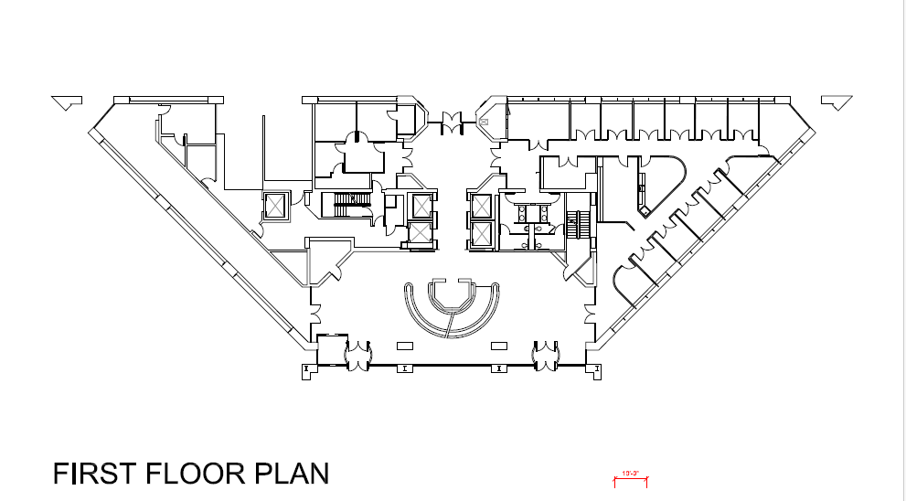

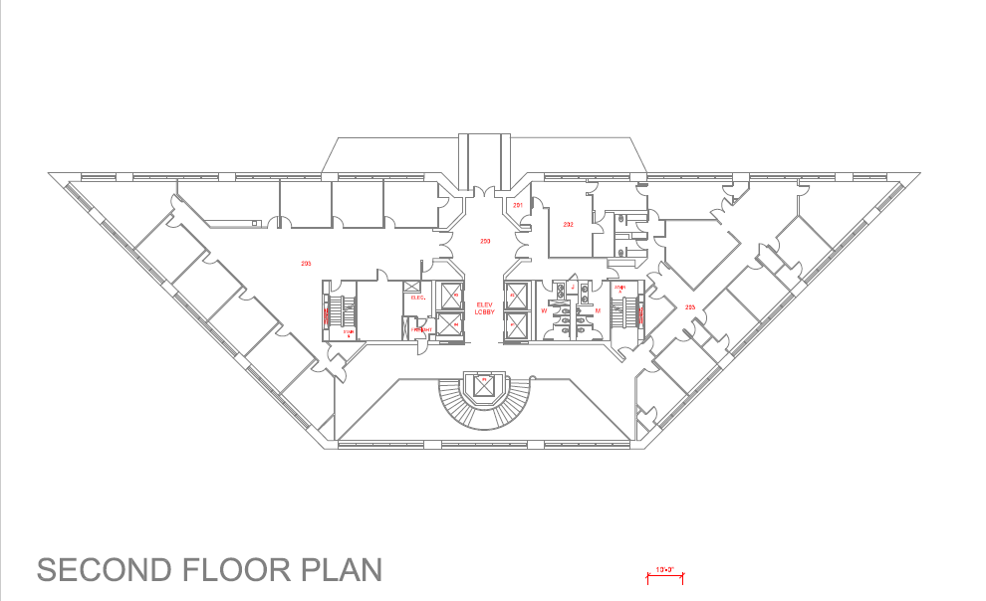

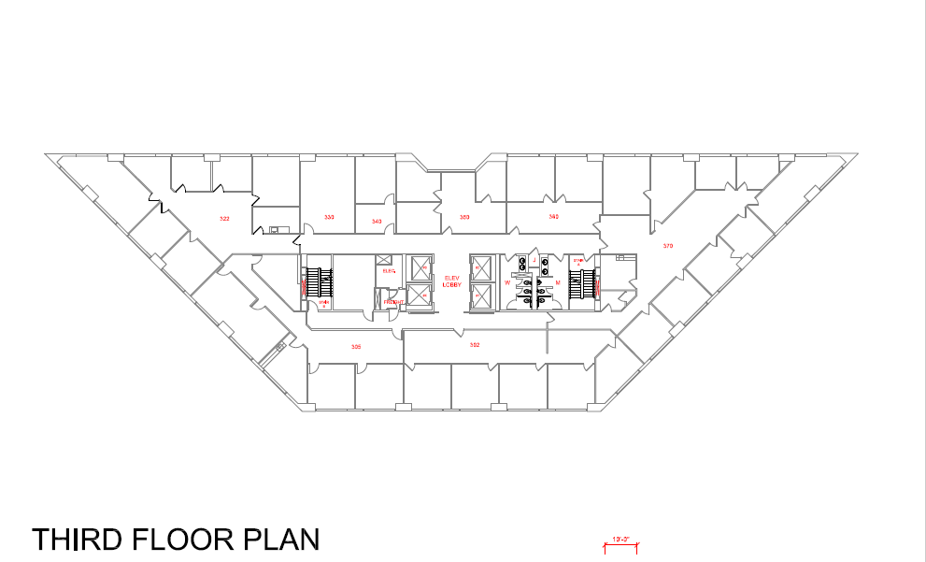

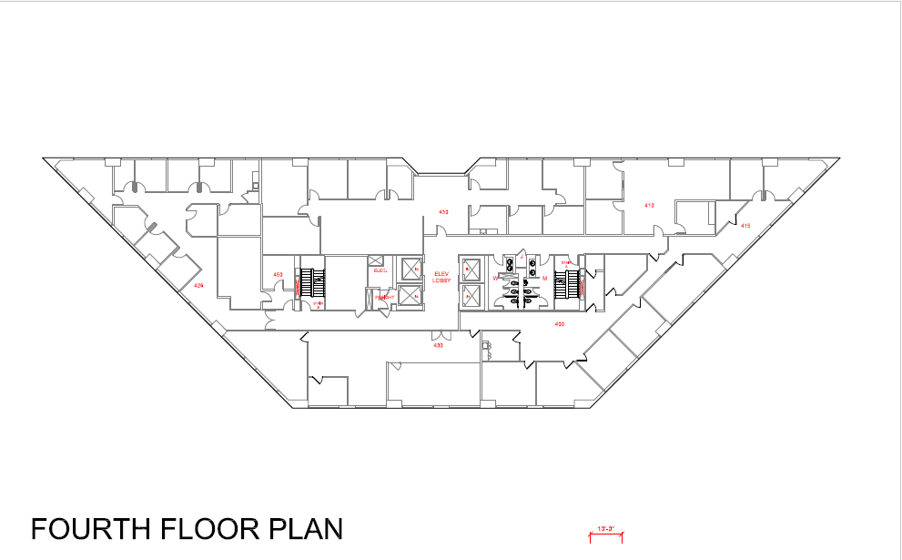

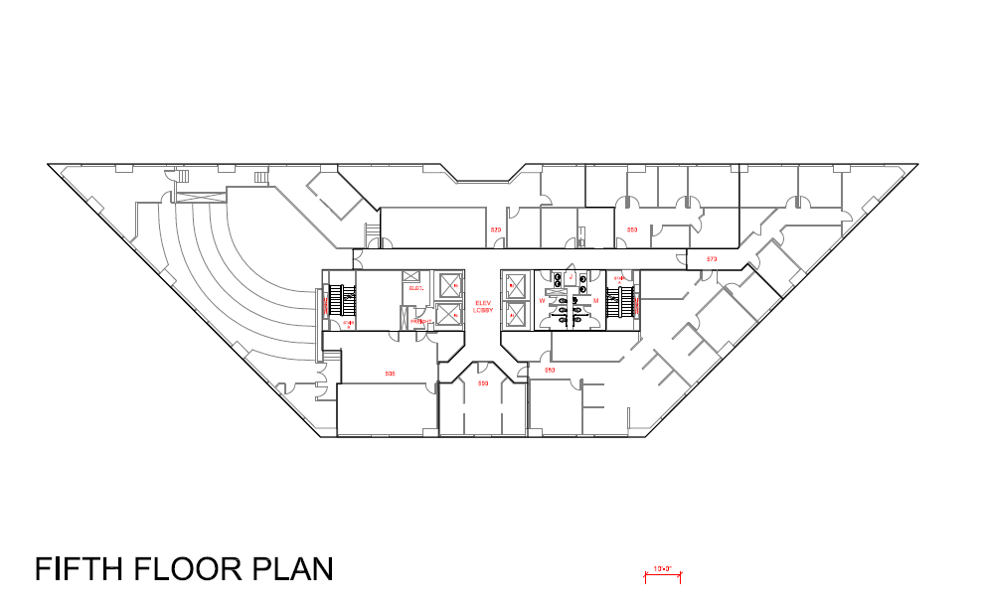

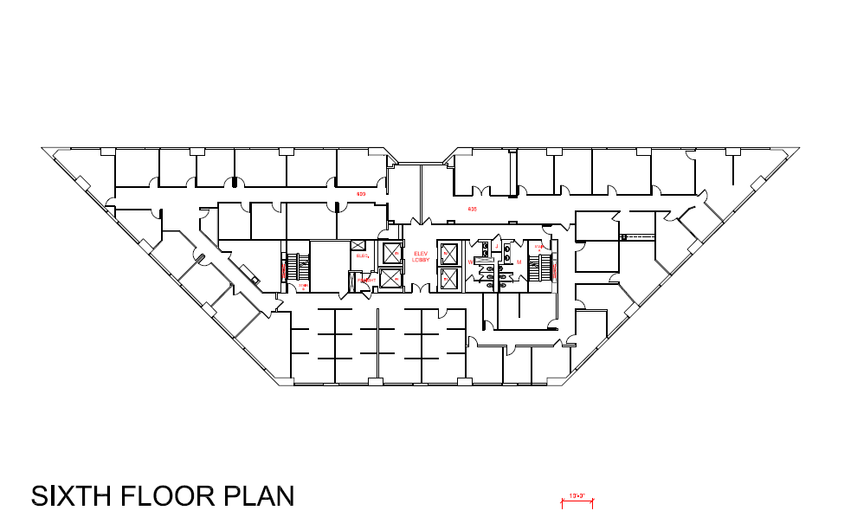

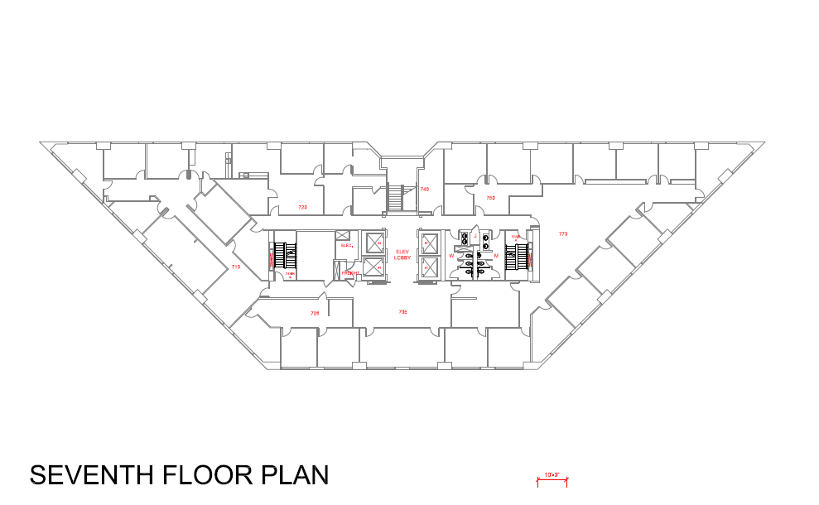

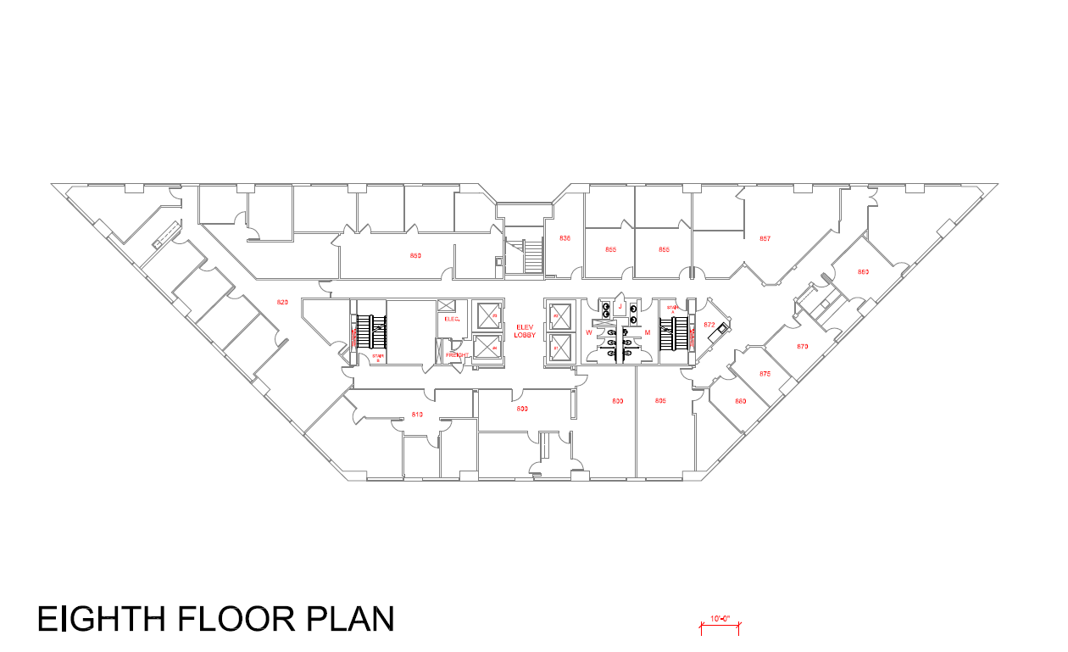

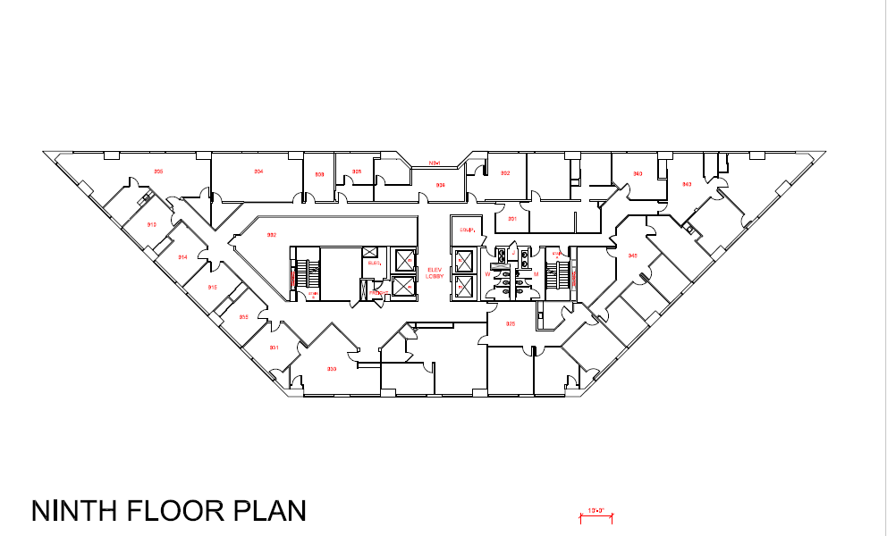

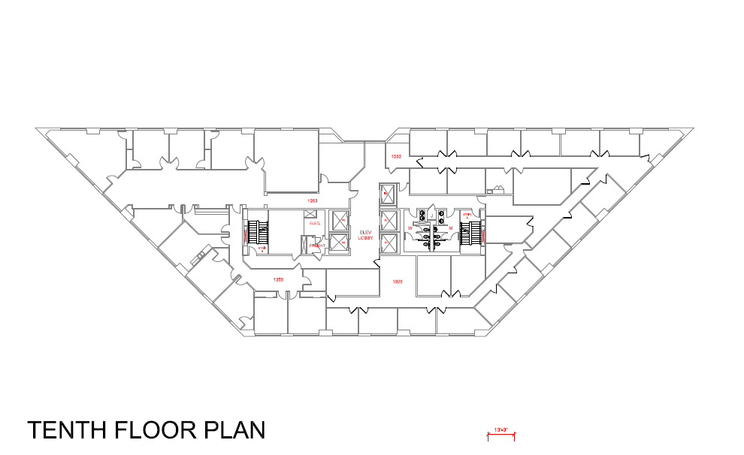

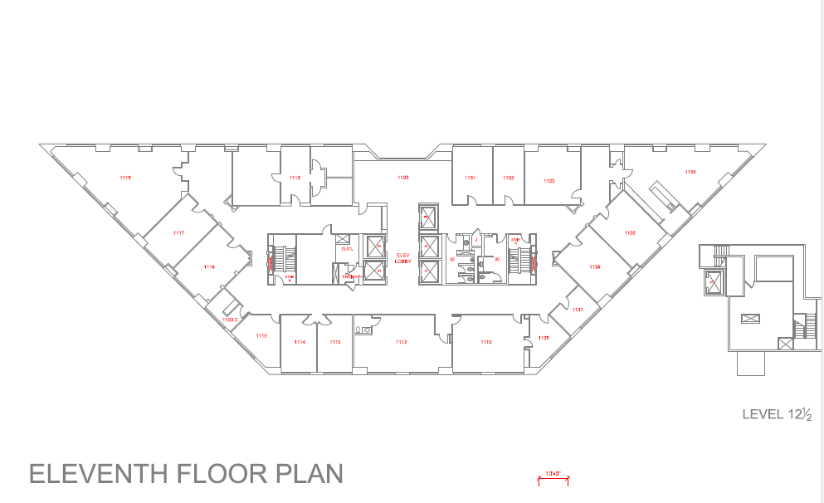

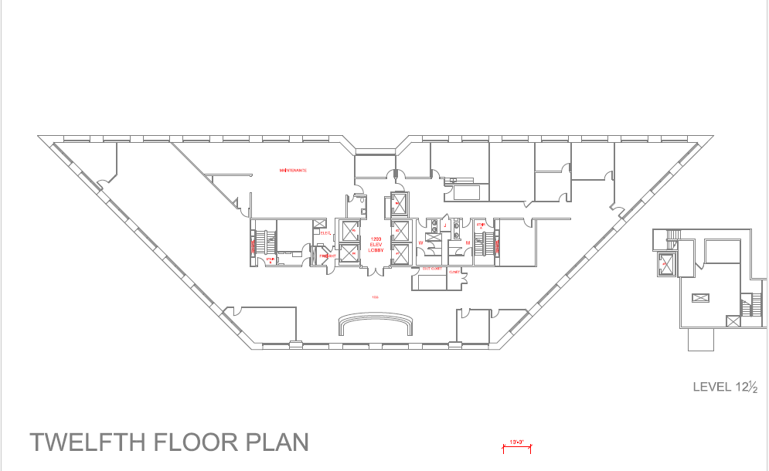

FIRE ALARM SYSTEM OPERATIONS

The following is a narrative of the fire alarm system and its method of operation.

I. The automatic building features initiated when:

A. One smoke detector in the corridor is activated:
- Sound a common alarm signal at the panel.
- Initiate device type and address on LCD display at the Fire Alarm Control Panel.
- Sound speakers on the floor of alarm, floor above and floor below.
- Flash strobes floor of alarm, floor above and floor below.
- Release all electrically held doors floor of alarm.
- Shut down AHU on the floor of alarm.
- Elevators automatically shut down with the doors open on the 1st or 2nd floor.
- Provide a signal to the remote fire alarm monitoring company.
- Fire alarm monitoring company contacts the fire department and building management in this order.

B. A second smoke detector is activated in the corridor:
Same as “A” above

C. One smoke detector is activated the elevator lobby:
Same as “A” above plus recall of elevators to second floor.

D. Second smoke detector is activated the elevator lobby:
Same as “A” above plus recall of elevators to second floor.

E. A fire alarm pull station is activated on an above ground floor:
Same as “A” above

F. A fire alarm pull station is activated on the ground floor:
Same as “A” above except sound signals of floors 1, 2 and 3

G. How do you activate a general alarm (alarm tone audible on all floors)?
- If the fire panel is in alarm - Hit All Evac. Button
- Activate the pull station in Fire Command Control room

BUILDING SAFETY FEATURES

COMMUNICATIONS: PUBLIC ADDRESS SYSTEM
PLUG IN PHONES FOR FIRE FIGHTERS

STAIRWELLS: TWO PRESSURIZED STAIRWELLS (“A” AND “B”) THAT LEAD TO THE 1st FLOOR

CORRIDORS: 2 HOUR FIRE RATED WALLS

ELECTRONIC LOCKS: 1st, 2nd, 4th, 6th 11th and 12th FLOORS WITH FIRE ALARM ACTIVATED EMERGENCY EGRESS.

FIRE COMMAND CENTER: LOCATED IN THE LOBBY ON THE WEST WALL

ELEVATORS: 4 PASSENGER ELEVATORS THAT RECALL TO THE 1st FLOOR or 2ND FLOOR.

HEATING, VENTILATION CHILLED WATER CENTRAL ZONE AIR
AND AIR CONDITIONING: HANDLERS.

SPRINKLER SYSTEM/ SPRINKLERED ON ALL FLOORS
STANDPIPE: STANDPIPE SYSTEM ZONED VERTICALLY IN STAIRWELL “A” AND “B”

EXTINGUISHING SYSTEMS: FIRE EXTINGUISHER CABINETS LOCATED BY BOTH STAIRWELLS ON EACH FLOOR WITH FIRE
EXTINGUISHERS.

EMERGENCY GENERATOR: OPERATES FIRE PUMP, EMERGENCY LIGHTING, FIRE PANEL AND ONE ELEVATOR.

FIREFIGHTERS OPERATIONAL INSTRUCTIONS
FOR ELEVATORS PHASE I & II

HALL SWITCH / PHASE I

RECALL ELEVATORS | - Insert Fire Key and Turn to “ON”
OVERRIDE ALARM RECALL | - Turn the Key to “BYPASS”
NORMAL OPERATION | - Turn the Key to “BYPASS”  - Then Turn the Key to “OFF”

CAR SWITCH / PHASE II
TO OPERATE CAR, HALL SWITCH OR ALARM MUST BE “ON” | - Insert Car Fire Key and Turn “ON”  - Press Desired Floor Number  - Press and hold “Door Close”
To Cancel Floor Selection | - Press “CALL CANCEL”
To Close Power Operated Doors | - Press and hold “DOOR CLOSE”
To Open Power Operated Doors | - Press and hold “DOOR OPEN”
To Hold Car at Floor | - With Doors Open, Turn to “HOLD”
To Automatically Send Car to Recall Floor | - With Doors Open, Turn to “OFF”

FIRE COMMAND CONTROL ROOM
BROADCAST MESSAGES

1. FALSE ALARM

ATTENTION – ATTENTION:
THIS IS “NOT” A FIRE EMERGENCY.
THIS IS A FALSE ALARM.
**************************************
THIS IS “NOT” A FIRE EMERGENCY.
THIS IS A FALSE ALARM.
**************************************
BUILDING ENGINEER IS INVESTIGATING THE ALARM.
RESUME NORMAL OFFICE ACTIVITIES.
THANK YOU FOR YOUR COOPERATION

2. TESTING – FIRE PANEL SYSTEM

ATTENTION – ATTENTION:
THIS IS “NOT” AN ACTUAL FIRE EMERGENCY.
BUILDING ENGINEERING IS TESTING THE FIRE ALARM SYSTEM.
**************************************
THIS IS “NOT” AN ACTUAL FIRE EMERGENCY.
BUILDING ENGINEERING IS TESTING THE FIRE ALARM SYSTEM.
**************************************
THIS IS “NOT” AN ACTUAL FIRE EMERGENCY.
RESUME NORMAL OFFICE ACTIVITIES.
THANK YOU FOR YOUR COOPERATION!

3. EXPERIENCING AN ALARM!

ATTENTION – ATTENTION:
THIS A FIRE ALARM.
BUILDING ENGINEERS ARE INVESTIGATING THE ALARM.
YOU WILL BE NOTIFIED WITH FURTHER INSTRUCTIONS, AS NECESSARY.
RESUME YOUR NORMAL OFFICE ACTIVITIES.
**************************************
BUILDING ENGINEERS ARE INVESTIGATING THE ALARM.
YOU WILL BE NOTIFIED WITH FURTHER INSTRUCTIONS, AS NECESSARY.
RESUME YOUR NORMAL OFFICE ACTIVITIES.
**************************************
BUILDING ENGINEERS ARE INVESTIGATING THE ALARM.
YOU WILL BE NOTIFIED WITH FURTHER INSTRUCTIONS, AS NECESSARY.
RESUME NORMAL OFFICE ACTIVITIES.
THANK YOU FOR YOUR COOPERATION.

4. ACTUAL FIRE EVENT
STAGE 1: When Designated To Do So

ATTENTION – ATTENTION:
THIS IS AN ACTUAL FIRE ALARM.
THIS IS AN ACTUAL FIRE ALARM.
FIRE WARDENS - DIRECT EMPLOYEES TO DESIGNATED STAIRWELLS.
AWAIT INSTRUCTIONS.
FIRE WARDENS – PREPARE TO EVACUATE BUILDING.
*************************************************
THIS IS AN ACTUAL FIRE ALARM.
FIRE WARDENS - DIRECT EMPLOYEES TO DESIGNATED STAIRWELLS.
AWAIT INSTRUCTIONS.
FIRE WARDENS – PREPARE TO EVACUATE BUILDING.

4.1 ACTUAL FIRE EVENT
STAGE 2 … When Designated To Do So

ATTENTION – ATTENTION:
FIRE WARDENS EVACUATE THE BUILDING.
FIRE WARDENS EVACUATE THE BUILDING.

This specific message is totally driven by the Fire Department Officers in the Fire Command Control Room; and they are in total command of this event. The full building evacuation, or the partial building evacuation is absolutely in accordance with the number of floors in the building, and the complete jurisdiction of the Fire Dept. Officers inside the FCC Room during the event, as to which floors and the necessary rescue procedures to be deployed.

5. BOMB THREAT
STAGE 1 … When Designated To Do So

ATTENTION – ATTENTION:
THIS IS A BOMB THREAT NOTIFICATION.
THIS IS A BOMB THREAT NOTIFICATION.
FIRE WARDENS – DIRECT YOUR EMPLOYEES TO THE DESIGNATED STAIRWELLS.
FIRE WARDENS – PREPARE TO EVACUATE THE BUILDING.
**************************************
FIRE WARDENS – DIRECT YOUR EMPLOYEES TO THE DESIGNATED STAIRWELLS.
FIRE WARDENS – PREPARE TO EVACUATE THE BUILDING.

5.1 BOMB THREAT
STAGE 2 … When Designated to Do So

ATTENTION – ATTENTION:
FIRE WARDENS EVACUATE THE BUILDING.
FIRE WARDENS EVACUATE THE BUILDING.

This specific message is totally driven by the Fire Department Bomb Squad Officers inside the Fire Control Command Room, and they are in total command of this event. The full building evacuation, or the partial building evacuation is absolutely in accordance to the number of floors in the building, and the complete jurisdiction of
the Fire Dept Officials/Bomb Squad Officers in the FCC Room during the event, as to which floors and, as necessary, the rescue procedures to be deployed.

